**Stock Bot Write-Up**

**Chart Trend Line**

**Daily Chart produced in Excel (Top) vs Yahoo Finance (Bottom)**

**RSI**

**RSI Produced in Excel Using Java Program Calculations (Top)**

**RSI taken from Yahoo Finance (Bottom)**

**Moving Average**

**MA Produced in Excel Using Java Program Calculations**

**Blue line represents chart trend line**

**Gray line represents Moving Average**

**Thoughts After Experimenting**

**Weekly Data vs Daily Data**

Using the weekly CSV file presented some issues when attempting to graph the RSI and Moving Average. Due to the limited amount of data, the RSI line was not graphed properly and would only show the RSI trend line when removing the first 26 weeks of data. Additionally, the MA trend line was not working either doing about the same thing and missing a vast part of the data.

Additionally, I noticed that because of the lack of data within the weekly CSV file, the trading bot was not performing as well as it should’ve. When parsing through the data, it managed to make money over the one-year period but it was a measly $700 profit. I figured if the stock bot had access to more data, such as the daily data, it would perform at a much higher rate. This was proven to be true when I downloaded the daily csv file of historical data. After this was done, my bot was exposed to much more data and was able to buy and sell at many daily, as opposed to weekly. The bot managed to win approximately $4,000 within the one year period.

I applied quite a few rules for the stock bot to follow in order to buy and sell accurately. The bot calculates multiple factors, such as the mean, variance, standard deviation, RSI and Moving Average. The bot would buy and sell based off of the moving average and standard deviation. Additionally, it was given rules such as selling 50% of stocks bought, if the stock price goes up by 10%. It sold 80% of stocks bought when the price would fall by 7%.

Below is a screenshot showing the success of the bot.

**Bot’s Functionality**

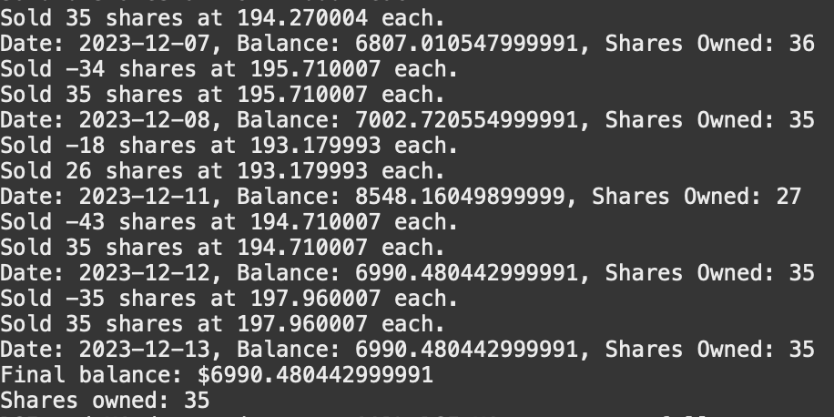

**The above picture shows the last few trades made**

The ending balance shows that $6990.48 is left over in addition to the 35 shares owned, which at the time of recording, are worth 197.92, bringing the total to approximately $14,000. Not bad with a starting balance of $10,000!